WAM Arm

Inertial Specifications

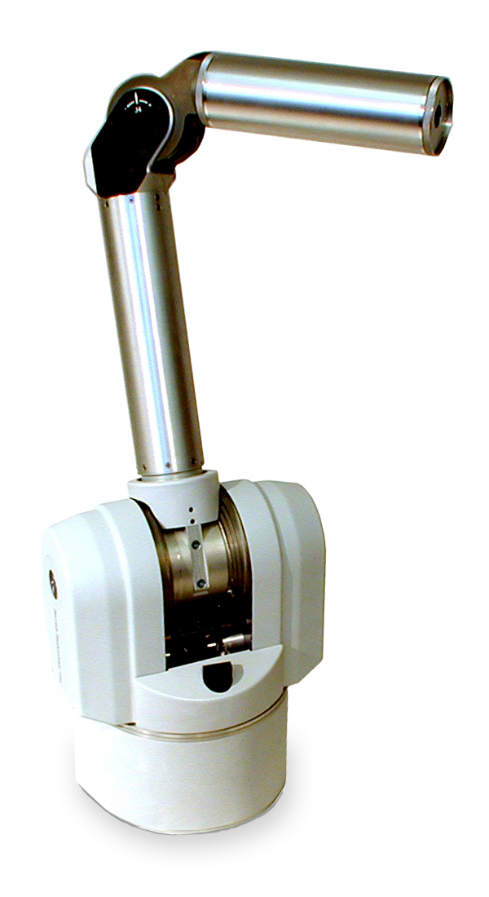



Document: D1005
Version: AA.00
Link 1 Relative to Frame 1

Principal Axes and Moments of Inertia (at center of mass)
Ix | (-0.0028, -0.0294, 0.9996) | kg∙mm²
Iy | (-0.0778, -0.9965, -0.0295) | kg∙mm²
Iz | (0.9970, -0.0779, 0.0006) | kg∙mm²
Px | 59,262.0287 | kg∙mm²
Py | 92,041.6447 | kg∙mm²
Pz | 95,176.7081 | kg∙mm²
Center of Mass (relative to frame 1)
m | 8.3936 | kg
x | 0.3506 | mm
y | 132.6795 | mm
z | 0.6286 | mm

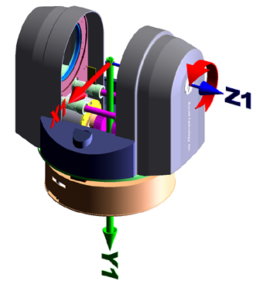
Moments of Inertia (at center of mass, aligned with frame 1)
Lxx | 95,157.4294 | kg∙mm²
Lyx | 246.1404 | kg∙mm²
Lzx | -95.0183 | kg∙mm²
Lxy | 246.1404 | kg∙mm²
Lyy | 92,032.3524 | kg∙mm²
Lzy | -962.6725 | kg∙mm²
Lxz | -95.0183 | kg∙mm²
Lyz | -962.6725 | kg∙mm²
Lzz | 59,290.5997 | kg∙mm²

Moments of Inertia (at frame 1)
Ixx | 242,919.8516 | kg∙mm²
Iyx | 636.5542 | kg∙mm²
Izx | -93.1687 | kg∙mm²
Ixy | 636.5542 | kg∙mm²
Iyy | 92,036.7003 | kg∙mm²
Izy | -262.6542 | kg∙mm²
Ixz | -93.1687 | kg∙mm²
Iyz | -262.6542 | kg∙mm²
Izz | 207,050.7372 | kg∙mm²

General note:
Mass does NOT include electrical
or mechanical cables
Link 2 Relative to Frame 2

Principal Axes and Moments of Inertia (at center of mass)
Ix | (-0.0105, 0.8944, 0.4472) | kg∙mm²
Iy | (-0.0165, -0.4473, 0.8942) | kg∙mm²
Iz | (0.9998, 0.0020, 0.0194) | kg∙mm²
Px | 20,106.7647 | 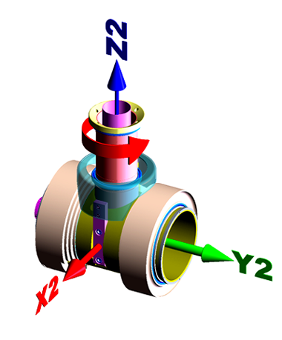kg∙mm²
Py | 23,479.5484 | kg∙mm²
Pz | 29,329.4065 | kg∙mm²
Center of Mass (relative to frame 2)
m | 4.8487 | kg
x | -0.2230 | mm
y | -21.3924 | mm
z | 13.3754 | mm

Moments of Inertia (at center of mass, aligned with frame 2)
Lxx | 29,326.8098 | kg∙mm²
Lyx | -43.3994 | kg∙mm²
Lzx | -129.2942 | kg∙mm²
Lxy | -43.3994 | kg∙mm²
Lyy | 20,781.5826 | kg∙mm²
Lzy | 1,348.6924 | kg∙mm²
Lxz | -129.2942 | kg∙mm²
Lyz | 1,348.6924 | kg∙mm²
Lzz | 22,807.3271 | kg∙mm²

Moments of Inertia (at frame 2)
Ixx | 32,413.1852 | kg∙mm²
Iyx | -20.2663 | kg∙mm²
Izx | -143.7579 | kg∙mm²
Ixy | -20.2663 | kg∙mm²
Iyy | 21,649.2574 | kg∙mm²
Izy | -38.6737 | kg∙mm²
Ixz | -143.7579 | kg∙mm²
Iyz | -38.6737 | kg∙mm²
Izz | 25,026.5101 | kg∙mm²

General note:
Mass does NOT include electrical
or mechanical cables
Link 3 Relative to Frame 3

Principal Axes and Moments of Inertia (at center of mass)
Ix | (0.0433, -0.9991, 0.0003) | kg∙mm²
Iy | (0.9855, 0.0427, 0.1641) | kg∙mm²
Iz | (-0.1639, -0.0068, 0.9864) | kg∙mm²
Px | 3,057.4904 | kg∙mm²
Py | 56,761.6071 | kg∙mm²
Pz | 56,807.8528 | kg∙mm²
Center of Mass (relative to frame 3)
m | 1.7251 | kg
x | -38.7565 | mm
y | 217.9078 | mm
z | 0.0252 | mm
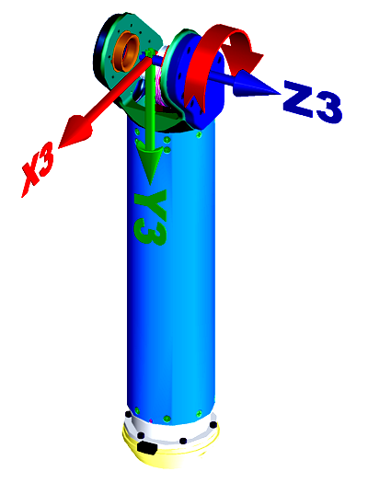

Moments of Inertia (at center of mass, aligned with frame 3)
Lxx | 56,662.2970 | kg∙mm²
Lyx | -2,321.6892 | kg∙mm²
Lzx | 8.2125 | kg∙mm²
Lxy | -2,321.6892 | kg∙mm²
Lyy | 3,158.0509 | kg∙mm²
Lzy | -16.6307 | kg∙mm²
Lxz | 8.2125 | kg∙mm²
Lyz | -16.6307 | kg∙mm²
Lzz | 56,806.6024 | kg∙mm²

Moments of Inertia (at frame 3)
Ixx | 138,575.0448 | kg∙mm²
Iyx | -16,890.4832 | kg∙mm²
Izx | 6.5293 | kg∙mm²
Ixy | -16,890.4832 | kg∙mm²
Iyy | 5,749.2209 | kg∙mm²
Izy | -7.1669 | kg∙mm²
Ixz | 6.5293 | kg∙mm²
Iyz | -7.1669 | kg∙mm²
Izz | 141,310.5180 | kg∙mm²

General note:
Mass does NOT include electrical
or mechanical cables
Link 4 Relative to Frame 4

Principal Axes and Moments of Inertia (at center of mass)
Ix | (-0.6527, 0.0050, 0.7576) | kg∙mm²
Iy | (0.1833, 0.9713, 0.1516) | kg∙mm²
Iz | (-0.7351, 0.2378, 0.6349) | kg∙mm²
Px | 584.4184 | kg∙mm²
Py | 1,206.9038 | kg∙mm²
Pz | 1,223.9595 | kg∙mm²
Center of Mass (relative to frame 4)
m | 0.4809 | kg
x | 26.6569 | mm
y | -0.2401 | mm
z | 25.9575 | mm

Moments of Inertia (at center of mass, aligned with frame 4)
Lxx | 950.9140 | kg∙mm²
Lyx | 0.9698 | kg∙mm²
Lzx | -315.7726 | kg∙mm²
Lxy | 0.9698 | kg∙mm²
Lyy | 1207.8530 | kg∙mm²
Lzy | 4.9096 | kg∙mm²
Lxz | -315.7726 | kg∙mm²
Lyz | 4.9096 | kg∙mm²
Lzz | 856.5147 | kg∙mm²

Moments of Inertia (at frame 4)
Ixx | 1,274.9810 | kg∙mm²
Iyx | -2.1088 | kg∙mm²
Izx | 16.9974 | kg∙mm²
Ixy | -2.1088 | kg∙mm²
Iyy | 1,873.6282 | kg∙mm²
Izy | 1.9118 | kg∙mm²
Ixz | 16.9974 | kg∙mm²
Iyz | 1.9118 | kg∙mm²
Izz | 1,198.2785 | kg∙mm²

General note:
Mass does NOT include electrical
or mechanical cables
Link 4 and Outer Link Relative to Frame 4

Principal Axes and Moments of Inertia (at center of mass)
Ix | (-0.1005, 0.0010, 0.9949) | kg∙mm²
Iy | (0.9949, 0.0036, 0.1005) | kg∙mm²
Iz | (-0.0035, 1.0000, -0.0014) | kg∙mm²
Px | 1,852.9293 | kg∙mm²
Py | 19,064.6829 | kg∙mm²
Pz | 19,340.6186 | 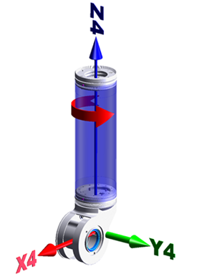kg∙mm²
Center of Mass (relative to frame 4)
m | 1.0912 | kg
x | 11.7534 | mm
y | -0.1092 | mm
z | 135.9144 | mm

Moments of Inertia (at center of mass, aligned with frame 4)
Lxx | 18,890.7885 | kg∙mm²
Lyx | -0.8092 | kg∙mm²
Lzx | -1,721.2915 | kg∙mm²
Lxy | -0.8092 | kg∙mm²
Lyy | 19,340.5969 | kg∙mm²
Lzy | 17.8241 | kg∙mm²
Lxz | -1,721.2915 | kg∙mm²
Lyz | 17.8241 | kg∙mm²
Lzz | 2,026.8453 | kg∙mm²

Moments of Inertia (at frame 4)
Ixx | 39,049.0802 | kg∙mm²
Iyx | -2.2101 | kg∙mm²
Izx | 21.9187 | kg∙mm²
Ixy | -2.2101 | kg∙mm²
Iyy | 39,649.6217 | kg∙mm²
Izy | 1.6243 | kg∙mm²
Ixz | 21.9187 | kg∙mm²
Iyz | 1.6243 | kg∙mm²
Izz | 2,177.6044 | kg∙mm²

General note:
Mass does NOT include electrical
or mechanical cables
Link 4 and Fixed Wrist Component Relative to Frame 4

Principal Axes and Moments of Inertia (at center of mass)
Ix | (-0.1829, 0.0035, 0.9831) | kg∙mm²
Iy | (0.0603, 0.9982, 0.0076) | kg∙mm²
Iz | (-0.9813, 0.0606, -0.1828) | kg∙mm²
Px | 2,579.8212 | kg∙mm²
Py | 9,999.4314 | kg∙mm²
Pz | 10,325.6396 | kg∙mm²
Center of Mass (relative to frame 4)
m | 2.0824 | kg
x | 6.2895 | mm
y | -0.0010 | mm
z | 111.0633 | mm

Moments of Inertia (at center of mass, aligned with frame 4)
Lxx | 10,065.3990 | kg∙mm²
Lyx | 14.6007 | kg∙mm²
Lzx | -1,392.4965 | kg∙mm²
Lxy | 14.6007 | kg∙mm²
Lyy | 10,000.5377 | kg∙mm²
Lzy | 29.4814 | kg∙mm²
Lxz | -1,392.4965 | kg∙mm²
Lyz | 29.4814 | kg∙mm²
Lzz | 2,838.9554 | kg∙mm²

Moments of Inertia (at frame 4)
Ixx | 35,752.4193 | kg∙mm²
Iyx | 14.5876 | kg∙mm²
Izx | 62.1491 | kg∙mm²
Ixy | 14.5876 | kg∙mm²
Iyy | 35,769.9341 | kg∙mm²
Izy | 29.2508 | kg∙mm²
Ixz | 62.1491 | kg∙mm²
Iyz | 29.2508 | kg∙mm²
Izz | 2,921.3314 | kg∙mm²

General note:
Mass does NOT include electrical
or mechanical cables
Link 5 Relative to Frame 5

Principal Axes and Moments of Inertia (at center of mass)
Ix | (-0.0004, 0.9999, -0.0139) | kg∙mm²
Iy | (1.0000, 0.0004, -0.0003) | kg∙mm²
Iz | (-0.0003, -0.0139, -0.9999) | kg∙mm²
Px | 172.3294 | kg∙mm²
Py | 321.0142 | kg∙mm²
Pz | 350.7125 | kg∙mm²
Center of Mass (relative to frame 5)
m | 0.3067 | kg
x | 0.0584 | mm
y | 28.3754 | mm
z | 0.1902 | mm

Moments of Inertia (at center of mass, aligned with frame 5)
Lxx | 321.0141 | kg∙mm²
Lyx | -0.0667 | kg∙mm²
Lzx | -0.0079 | kg∙mm²
Lxy | -0.0667 | kg∙mm²
Lyy | 172.3637 | kg∙mm²
Lzy | -2.4724 | kg∙mm²
Lxz | -0.0079 | kg∙mm²
Lyz | -2.4724 | kg∙mm²
Lzz | 350.6782 | kg∙mm²

Moments of Inertia (at frame 5)
Ixx | 567.9724 | kg∙mm²
Iyx | 0.4416 | kg∙mm²
Izx | -0.0045 | kg∙mm²
Ixy | 0.4416 | kg∙mm²
Iyy | 172.3759 | kg∙mm²
Izy | -0.8172 | kg∙mm²
Ixz | -0.0045 | kg∙mm²
Iyz | -0.8172 | kg∙mm²
Izz | 597.6265 | kg∙mm²

General note:
Mass does NOT include electrical
or mechanical cables
Link 6 Relative to Frame 6

Principal Axes and Moments of Inertia (at center of mass)
Ix | (-0.0004, -0.9712, 0.2384) | kg∙mm²
Iy | (0.0020, -0.2384, -0.9712) | kg∙mm²
Iz | (1.0000, 0.0001, 0.0021) | kg∙mm²
Px | 253.9995 | kg∙mm²
Py | 523.2057 | kg∙mm²
Pz | 604.1925 | kg∙mm²
Center of Mass (relative to frame 6)
m | 0.4278 | kg
x | -0.0311 | mm
y | -14.8635 | mm
z | 25.6326 | mm

Moments of Inertia (at center of mass, aligned with frame 6)
Lxx | 604.1921 | kg∙mm²
Lyx | 0.0825 | kg∙mm²
Lzx | -0.1896 | kg∙mm²
Lxy | 0.0825 | kg∙mm²
Lyy | 269.3020 | kg∙mm²
Lzy | -62.3326 | kg∙mm²
Lxz | -0.1896 | kg∙mm²
Lyz | -62.3326 | kg∙mm²
Lzz | 507.9036 | kg∙mm²

Moments of Inertia (at frame 6)
Ixx | 979.8079 | kg∙mm²
Iyx | 0.2804 | kg∙mm²
Izx | -0.5308 | kg∙mm²
Ixy | 0.2804 | kg∙mm²
Iyy | 550.3998 | kg∙mm²
Izy | -225.3322 | kg∙mm²
Ixz | -0.5308 | kg∙mm²
Iyz | -225.3322 | kg∙mm²
Izz | 602.4224 | kg∙mm²

General note:
Mass does NOT include electrical
or mechanical cables
Link 7 Relative to Frame 7

Principal Axes and Moments of Inertia (at center of mass)
Ix | (1.0000, -0.0004, 0.0000) | kg∙mm²
Iy | (0.0004, 1.0000, 0.0002) | kg∙mm²
Iz | (0.0000, -0.0002, 1.0000) | kg∙mm²
Px | 21.4102 | kg∙mm²
Py | 21.6157 | kg∙mm²
Pz | 42.1975 | kg∙mm²
Center of Mass (relative to frame 7)
m | 0.0557 | kg
x | -0.0001 | mm
y | -0.1823 | mm
z | -284.7431 | mm

Moments of Inertia (at center of mass, aligned with frame 7)
Lxx | 21.4102 | kg∙mm²
Lyx | -0.0001 | kg∙mm²
Lzx | 0.0000 | kg∙mm²
Lxy | -0.0001 | kg∙mm²
Lyy | 21.6157 | kg∙mm²
Lzy | 0.0040 | kg∙mm²
Lxz | 0.0000 | kg∙mm²
Lyz | 0.0040 | kg∙mm²
Lzz | 42.1975 | kg∙mm²

Moments of Inertia (at frame 7)
Ixx | 4,536.8120 | kg∙mm²
Iyx | -0.0001 | kg∙mm²
Izx | 0.0011 | kg∙mm²
Ixy | -0.0001 | kg∙mm²
Iyy | 4,537.0156 | kg∙mm²
Izy | 2.8944 | kg∙mm²
Ixz | 0.0011 | kg∙mm²
Iyz | 2.8944 | kg∙mm²
Izz | 42.1994 | kg∙mm²

General note:
Mass does NOT include electrical
or mechanical cables

